SOP Name: Unevenly Loaded Containers _ Blue Magnet

SOP Applies to: Corporate Operations, Franchise Operations, Logistics

Prepared by |  | Effective Date
One Network Asset Management Task Force |  | 5/11/2020

OVERVIEW:
To enhance the safety of forklift operation, it is vital that unevenly loaded containers are properly identified and handled at all storage and transportation facilities. In such cases, where one side of the container is significantly heavier than the other, there are considerable safety risks when containers are carried by forklifts. If not handled appropriately, the imbalance in weight distribution can cause containers to fall from the forklifts.
Such mishandling creates the potential for:
- Severe and possibly fatal bodily injury
- Damage to the customer contents
- Damage to PODS containers
- Damage to forklifts
- Damage to warehouse floors
Due to the physical danger and financial impact of such incidents, adherence to the following procedures is critical for the identification, handling and storage of unevenly loaded containers.

IDENTIFICATION:
In cases where unevenly loaded containers are identified while the customer is present, management can make the determination to have the customer re-arrange the contents prior to storage or re-delivery. However, in most cases, unevenly loaded containers should be identified by the forklift operator. When moving any container, the forklift operator should always raise the container a few inches and assess the stability before proceeding with the full lift. As shown below, a container will tilt to one side when the load is not balanced.
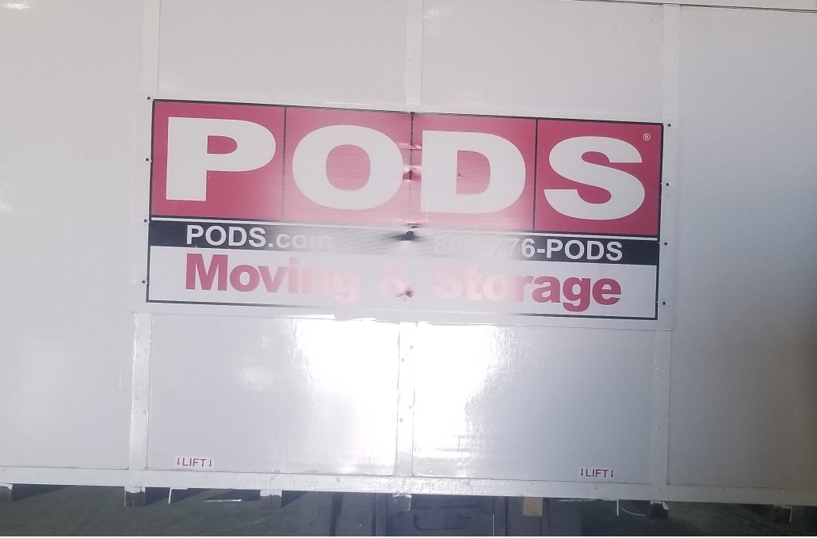
Once an uneven load is identified, the container must be clearly marked with two blue magnets on the heavy end of the container. As shown below, the magnets should be affixed to the upper 1/3rd of the corner metal posts on both sides of the container, clearly visible to the forklift operator. Further, these magnets should remain affixed to the container during IF transportation. In doing so, forklift operators at both HUB and destination facilities will be made aware of the uneven load. These magnets (part #RCU911), are available for purchase on the PODS Portal.


Under previous guidance, unevenly loaded containers were marked with a blue “X” or “unbalanced load” decal. However, such markings have created issues with container appearance. The blue “X” can be difficult to remove and often leaves a permanent stain or residue. Further, the “unbalanced load” or “heavy” decals have caused transportation issues when passing through weigh stations and undergoing other inspections. Accordingly, the use of such markings is no longer acceptable.
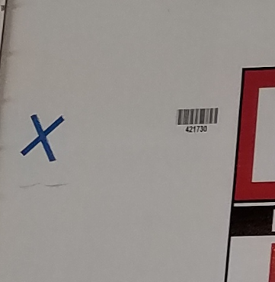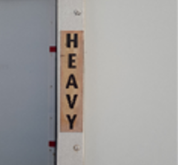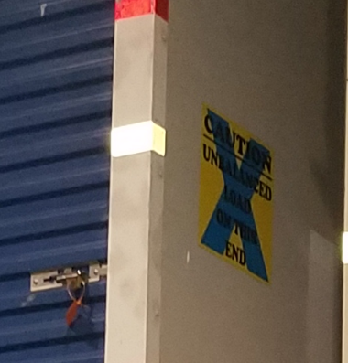

Handling and Storage
Unevenly loaded containers should be handled with enhanced caution. The container must be stored on the ground level of the warehouse and in no cases should exceptions be made.
To lift an unevenly loaded container:
- Lift at a gradual pace from the floor or truck bed, pausing a few inches from the ground to gauge stability
- With the container lifted six to eight inches from the floor, move slowly and cautiously through the facility, ensuring proper distance from other associates in accordance with the Forklift Policy
- For pre-Gen 5 containers, the forks may need to enter the pockets off-center to compensate for the uneven weight distribution (see image below)
- For Gen-5 and newer containers, off-center lifting is not an option as the forks can only be inserted through the designated pockets
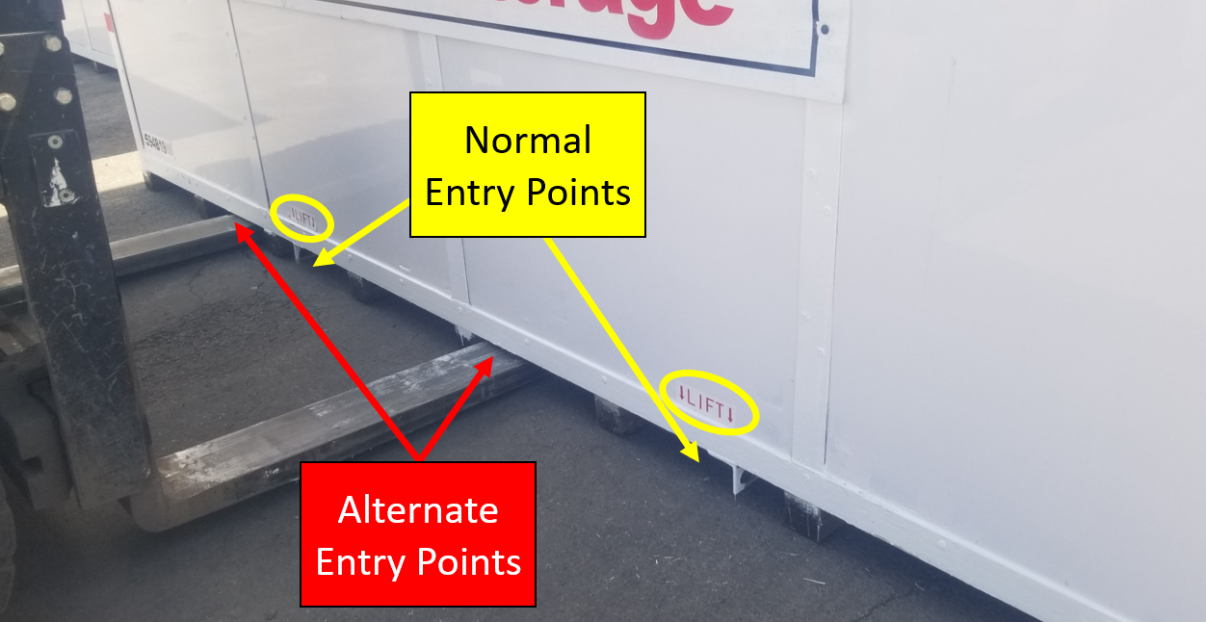

Removal
The magnets should only be removed from the container upon loading for final delivery to the customer or self-FPU in the storage center. In doing so, the container will not be delivered to the next customer with the magnets still attached.

Questions/Comments
Any questions or comments surrounding this policy should be forwarded to the SVP of Corp. Ops, Franchise Development Management team or the Director of Internal Audit.

SOP Revision History:
Date Revised by Revision Description
5/11/2020 David Juan New
5/17/2021 David Juan Transportation Height

